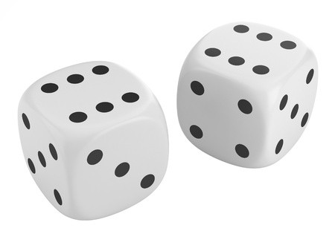

ROLL in the NEW YEAR !

Sunday | Monday | Tuesday | Wednesday | Thursday | Friday | Saturday
Scan the QR code for a  video of each exercise! |  |  | 1 | 2 | 3 | 4
5 | 6 | 7 | 8 | 9 | 10 | 11
12 | 13 | 14 | 15 | 16 | 17 | 18
19 | 20 | 21 | 22 | 23 | 24 | 25
26 | 27 | 28 | 29 | 30 | 31

Student: _________________________________________ Grade: ______ Days Completed: _________

Parent Signature: _______________________________ Teacher:___________________________________

ROLL in the NEW YEAR !

Directions: Roll two dice and add the numbers together. The sum of the dice determines the exercise movement. Your workout should consist of at least 10 rolls of the dice. However, if you’re feeling extra motivated, roll a few extra times to intensify your workout!
Roll a 2 – 20 Star Jumps
Roll a 3 – 20 Speed Skaters
Roll a 4 – 10 Burpees
Roll a 5 – 10 Squat Jumps
Roll a 6 – 25 Skier Jacks
Roll a 7 – 25 Jumps (with a jump rope if possible)
Roll an 8 – 10 Plank-to-Low Squats
Roll a 9 – 5 Pushups
Roll a 10 – 10 Hip Bridges
Roll an 11 – 20 Calf Raises.
Scan this QR code to see a video of each exercise!

Roll a 12 – 10 Crab Toe Touches.

Complete the ROLL in the NEW YEAR fitness challenge throughout the month of January. Using the calendar, write your initials for each day you complete a workout. At the end of the month, have your parents sign the bottom of the calendar, and return it to your PE teacher for an award certificate.

