CONGRATULATIONS

PLAY FOR FITNESS!

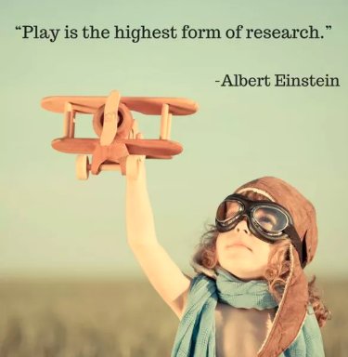

______________ December 31, 2018

